ROLE PROFILE

REGISTERED MANAGER
Job Title | Registered Manager | Department
Reporting To | Regional Service Lead, LD&A
Location | Complex Care – Kingswood House, Cresswell | Evaluation Date

Elysium Healthcare, as the UK leader in specialist psychiatric services, operate throughout England and Wales caring for people with mental illness, learning disabilities and acquired brain injuries. It also provides employee assistant programmes.

It is the objective of the Elysium Healthcare to be the independent sector provider of choice in our field. We are committed to responding positively to the needs of our customers and to delivering services of measurable quality.

The business has four types of customers: service users, staff, purchasers and external agencies.

Service Users may suffer from mental illness, personality disorder and/or learning disabilities. Service users within the complex care services are subject to Deprivation of Liberty Safeguards. Referrals are taken from many sources including inpatient hospitals, residential and community services.
The workforce of the organisation is multidisciplinary; a significant proportion of those employed are in a clinical discipline with other departments providing supporting services.

JOB PURPOSE

- Overall operational management of Kingswood House, leadership and development of all departments.
- To maximise the financial performance of Kingswood House, whilst maintaining high quality service standards.
- To develop the business potential of Kingswood House and new developments within area of responsibility.
- To be an active member of the Regional Clinical Governance (RCG) and Regional Operational Governance (ROG) group for the Midlands and North.
- To participate in the Senior Nurse on call rota for the region.

ORGANISATIONAL CHART

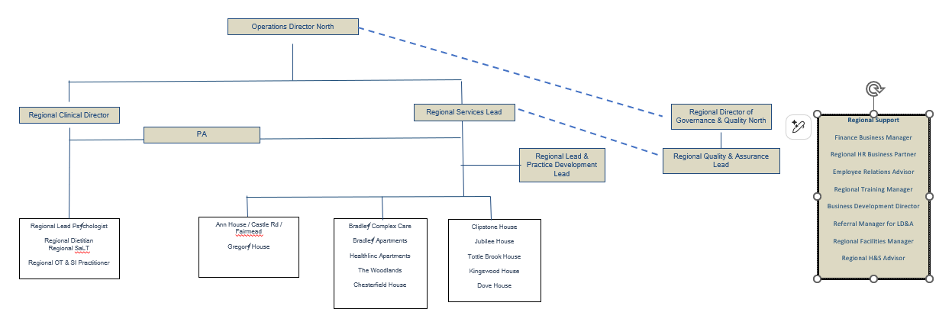

KEY OBJECTIVES

- The achievement of Kingswood House business and financial objectives on an annual basis.
- Develop proactive, positive relationships with internal and external customers which needs to business development and quality care.
- The appropriate leadership, management and motivation of employees with an active development of a pride in effectiveness and good teamwork.
- Ensure the good marketing of Kingswood House and its facilities, monitor market conditions, competition and trends. Proactive response to market challenges.
- To be the Registered Manager under the legislation of the Health and Social Care Act 2008 and associated regulations.
- Compliance with all company policies and legislation requirement including financial, health and safety, clinical and all areas under corporate and clinical governance. Compliance with Care Quality Commission (CQC).
- Contribution and participation as an individual and as a representative of Kingswood House to the corporate development of Elysium Healthcare, Mids & North.
- The development of practices that will enhance the performance of Kingswood House in line with company policy.
- Through annual key objectives, set targets to ensure that Kingswood House activities are delivered on time and to an agreed standard. Develop corrective actions when deficiencies arise.
- Set high personal and professional standards in line with the Company’s code of conduct.
- Budget planning.
- To recruit, develop, motivate and retain good quality staff at Kingswood House.
- Maintain an excellent reputation within the local area as a healthcare provider, employer and a valued integrated part of the local community.
- Continued attainment of relevant external accreditation, for example IIP.
- To assist the Operations Director & Regional Operations Lead in audit reports to comply with Health and Social Care Act 2008 and associated regulations.
- To oversee health and safety policy procedure for Kingswood House.
- To audit on an annual basis all matters of health and safety.

KEY PERFORMANCE INDICATORS

Key Performance Indicators
- Deliver unit objectives and performance targets within defined timescales.
- External customers satisfaction with the quality of services being provided.
- Growth of the unit’s business case.
- Submission of all required reports within defined guidelines.
- Satisfactory internal and external audit, inclusive of internal provided compliance processes and Care Quality Commission (CQC).
- Meet the required standards detailed in the Health and Social Care Act 2008 and associated regulations.
- Manage services within budgetary agreements.

DECISIONS AND JUDGEMENTS

- Day to day management strategic development at Kingswood House
- 24-hour management of the region when on call.
- Within company guidelines.
- Advice on issues within scope of expertise.

COMMUNICATION AND RELATIONSHIPS

- Operations Director North & Regional Service Lead, LD&A
- Regional Operations and Clinical Governance Group
- Unit Operational and Governance Groups
- Head/Leads of Departments
- Care Pathways
- Regional colleagues
- Support Services
- All staff
- External Agencies
- Contractors
- Regulators
- Business customers
- Referrers

NEED TO BE

- High Profile Leader
- High Integrity
- Creditable style that engenders confidence
- Energetic and enthusiastic, cross directorate/function aware
- Visionary

- Humanistic and encouraging
- Accomplished manager
- Creative problem solver
- Influence the thinking of others
- Time management
- High achiever and effective decision maker
- Supportive and willing to learn
- Responds positively to constructive feedback.
- Good team player
- Good motivator
- Good communicator
- Resilient able to stay calm under pressure

KNOWLEDGE, TRAINING AND EXPERIENCE

Skills/Knowledge
- Highly articulate in spoken and written communication skills.
- Ability to provide commercial input at senior management level.
- Confident, adaptable, resilient and commercially aware.
- High degree of presence and ability to engage people.
- Able to gain trust and maintain credibility whilst utilising resources.
- Keeps up to date with current and new management thinking.
- Knowledge of business strategy, planning, financial management, HR legislation, management development and organisational change.
- Knowledge of non-clinical operational activities within a health sector organisation.
- Current issues in learning disability and mental health issues at MDT level.
- Understating diversity issues.
- Working knowledge of the independent healthcare sector organisation.

Training
- Graduate caliber with possible postgraduate degree.
- Evidence of general senior management development preferably within the health sector

Experience
- 5 years managerial experience within a senior management role.
- Proven track record of achieving goals and targets
- Operational experience of health sector, more so learning disability and mental health sector

HEALTH, SAFETY AND SECURITY

To take personal responsibility for ensuring the work practices and the environment meet the requirements of the Health and Safety at Work legislation. Develop and submit action plans to ROG to rectify the deficit.
All employees have a responsible for the safeguarding of service users within Elysium Healthcare. Employees have a duty to attend the training provided by Elysium Healthcare regarding Safeguarding Adults and Safeguarding Children. Employees must make themselves familiar with the types of abuse, the signs that abuse has taken place and the definition of a vulnerable adult. Employees will report all safeguarding incidents to their line manager and use the Incident recording document to record all the required detailed information.
This job description forms the broad framework within which the incumbent will undertake his/her duties and will be the subject of regular review with the post holder.

EQUALITY AND DIVERSITY

It is the responsibility of every person to act in ways that support equality and diversity. Equality and diversity are related to the actions and responsibilities of everyone – users of services including service users, clients and carers; work colleagues; employees and people in other organisations.

- Acts in accordance with legislation, policies, procedures and good practice
- Treats everyone with dignity and respect
- Allows others to express their views even when different from one’s own
- Does not discriminate or offer a poor service because of others’ differences or different
viewpoints.

I have read my role description and understand its contents and believe that I can achieve all expectations required.

SIGNED (POST HOLDER) | DATE |

SIGNED (LINE MANAGER) | DATE |

